Issuance Date: 7/6/22
Revised Date: 6/15/23

CONTRACT PERIOD/RENEWAL OPTIONS
Current Contract Period: July 6, 2023 through September 5, 2023
Original Contract Period: July 6, 2022 through July 5, 2023
Available Renewal Period Options: 0
Potential Final Expiration Date: September 5, 2023

ALL PURCHASES MADE UNDER THESE CONTRACTS MUST BE FOR PUBLIC (STATE AGENCY) USE ONLY. PURCHASES FOR PERSONAL USE BY PUBLIC EMPLOYEES OR OFFICIALS ARE PROHIBITED.

A state agency shall be defined as a division, section, bureau, office, program, board, regional/district office, etc., that exists within a department of Missouri State Government. For the purposes of this document, this shall also include the Judicial and Legislative branches of the State of Missouri.

BUYER CONTACT INFORMATION
Name: | Jennie Rees
Email: | jennie.rees@oa.mo.gov
Phone Number: | (573) 751-6442

ORGANIZATION

Statewide Contract History
Contract Information
Instructions and Information
Contract Scope of Work
Appendix A – Satisfactory Survey

Attachment 1 – Passenger Vehicles (separate document)
Attachment 2 – Light Duty Trucks and Work Vans (separate document)
Attachment 3 – Medium duty Trucks and Cargo Vans (separate document)
Attachment 4 – Patrol Vehicles (separate document)
Attachment 5a – Motor Vehicle Price Quote Request Form (separate document)
Attachment 5b – Motor Vehicle Price Quote Request Form Award Record(separate document)
Attachment 6 – Domestic Products Procurement Act (separate document)

STATEWIDE CONTRACT HISTORY

The following table summarizes actions related to this Notification of Statewide Contract:

ACTION ISSUE DATE | SUMMARY OF CHANGES
6/15/23 | Contract extension through September 5, 2023.
6/5/23 | Added additional contractor as a result of bidding RFPC30034902302255. Contract CC232255001 was awarded and has been added as an additional qualified vendor. Agencies must include this vendor when requesting quotes for the specific categories awarded to this vendor.
5/22/23 | Updated contract CC231422004 to contract number CC231422006 due to an assignment of contract from Putnam Chevrolet to Ed Morse Chevrolet North.
3/16/23 | Updated the contact information for Putnam Chevrolet, Inc. (CC231422004) to Derek VanLoo. Also corrected a typo in Corwin’s email address within the email distribution lists.
3/3/23 | See below for an update to Ford’s current Order Bank dates:  Ford Vehicle Line Ordering Summary as of 2/27/23  24MY Vehicle Order Bank Open Date Order Bank Close Date  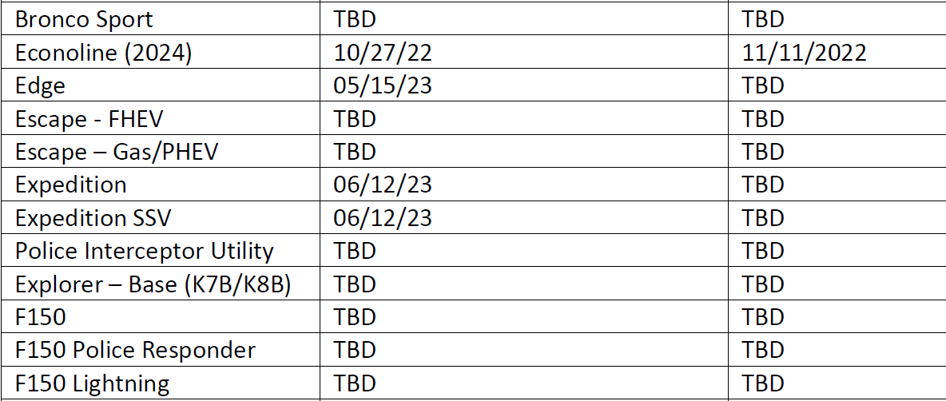  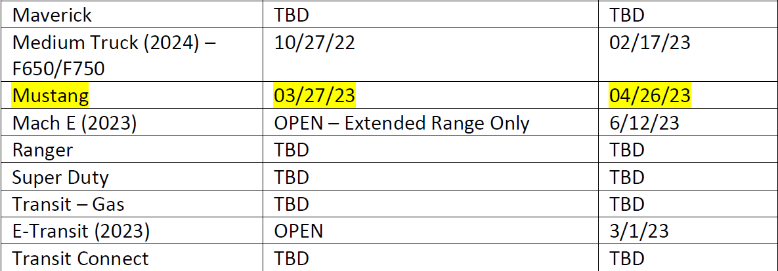
1/19/23 | Added additional contractors as a result of bidding RFPC30034902301422. Contracts CC231422001-005 were awarded and have been added as additional qualified vendors. Agencies must include these vendors when requesting quotes for the specific categories awarded to these vendors.  Also updated contract CC230582001 to contract number CC230582003 due to an assignment of contract from Scheppers International Truck Center to Rush Truck Center Jefferson City.
12/2/22 | Added additional contractors as a result of bidding RFPC30034902300582. Contracts CC230582001 and CC230582002 were awarded and have been added as additional qualified vendors. Agencies must include these vendors when requesting quotes for the specific categories awarded to these vendors.  Also updated contract CC222374006 to contract number CC222374009 due to an assignment of contract from Lou Fusz Ford to Lou Fusz Motor Company.
11/22/22 | See below for an update to Ford’s current Order Bank dates:  Ford Vehicle Line Ordering Summary as of November 20, 2022  23MY Vehicle Order Bank Open Date Order Bank Close Date  Super Duty 11/28/2022 1/13/2023
10/25/22 | See below for an update to Ford’s current Order Bank dates:  Econoline (2024) 10/27/2022 TBD  Medium Truck (2024) – F650/F750 10/27/2022 TBD  Super Duty 11/14/2022 12/16/2022
10/17/22 | See below for an update to Ford’s current Order Bank dates:  E-Transit 8/26/22 3/1/23
10/12/22 | See below for an update to Ford’s current Order Bank dates:
10/6/22 | See below for an update to Ford’s current Order Bank dates:  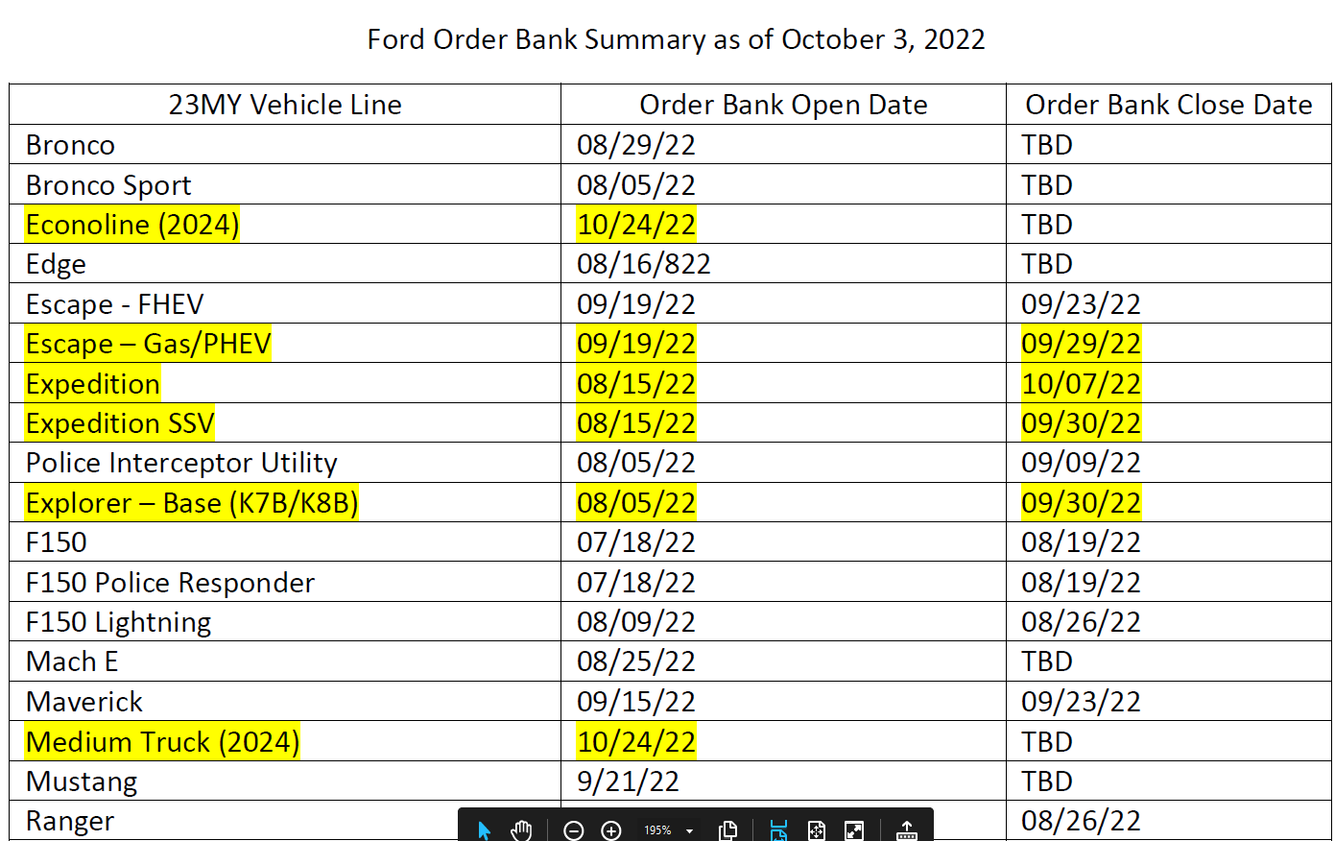  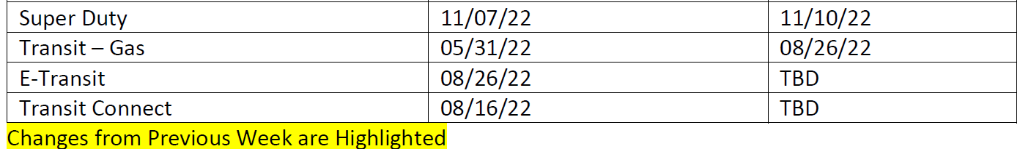
10/5/22 | Updated the list of categories under section 8. Purchase Order Requirements to include which SamII line item should be used for each category. The list is the same for all contractors.
9/22/22 | Due to the overwhelming response of the order banks opening, Ford has notified the Division that the order banks for the Maverick and the Escape will be closing 9/23/22 by close of business.

9/20/22 | See below for an update to Ford’s current Order Bank dates:  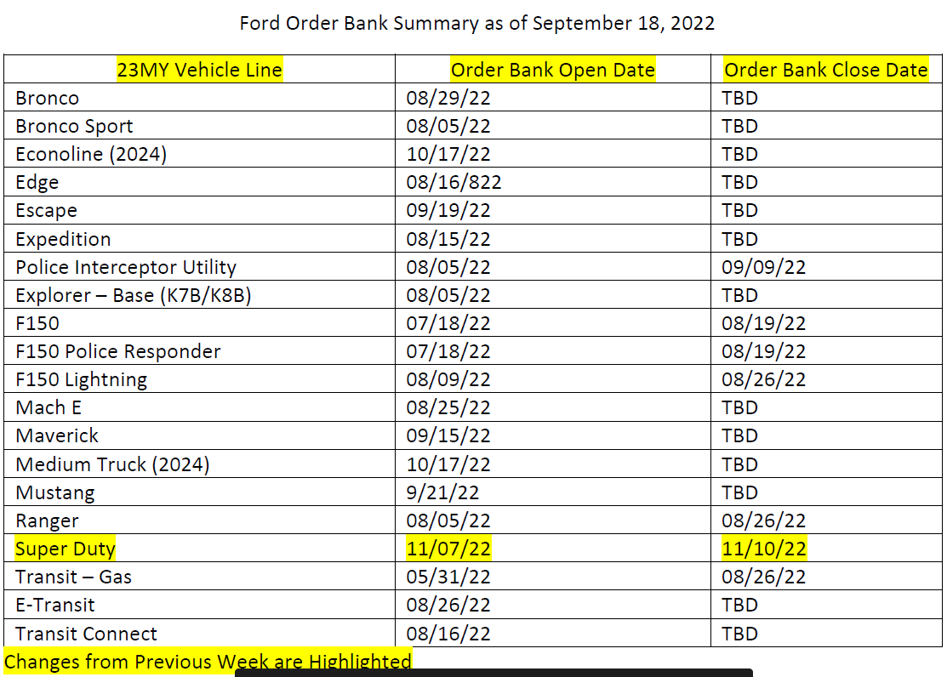
9/16/22 | Dodge Order Bank Update:  - Heavy Duty Series for Ram opened today… 09.12.22; Ram 2500, 3500, 4500 & 5500 series  - Ram Light Duty Segment.. 1500 series, DT- Platform opened roughly 2 ½ weeks ago  - Jeep Gr. Cherokee… WL series open  - Jeep Gladiator… JT series open  Law Enforcement  - Durango Pursuit… Anticipate will open later this week (Thurs/Friday… 15th/16th)  - Charger Pursuit… Early October  - Ram SSV…. Early October

9/12/22 | See below for Ford’s current Order Bank dates:  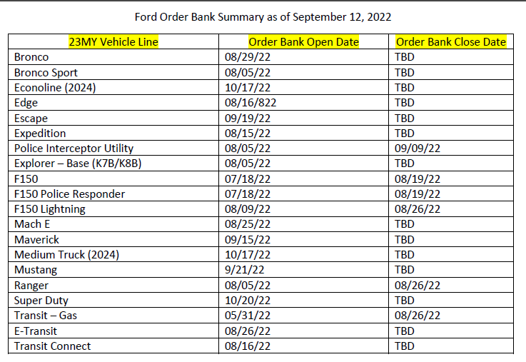
8/11/22 | Added a note under the “Contract Information” section for agencies that indicates all email requests for pricing on Dodge, Jeep, Ram and/or Chrysler vehicles should have Jose Lerma copied on the requests. Jose Lerma represents the manufacturer (Stellantis rep) and will assist the dealers with getting the right price concessions when requesting pricing for Dodge, Jeep, Ram, and/or Chrysler vehicles.
7/19/22 | Included Attachments 1-6 as separate documents. The Signature Line for the State Fleet Manager approval was removed from Attachment 5b. The Fleet Manager’s approval process for vehicles is consistent with the process that has been in place for previous contracts. Added commodity code information to section 8 – Purchase Order Requirements.
7/11/22 | Added information regarding included categories. Also added email distribution lists per category that agencies can copy into their email when sending out the Price Quote Form to vendors.
7/6/22 | Initial issuance of new contracts.

CONTRACT INFORMATION

CC222374001
MissouriBUYS SYSTEM ID: MB00181437
Contractor Name: Canoo Technologies Inc.
Contractor Address: 15520 HWY 114
Suite 2C
Justin, TX 76247
Contact Information: |  | Name: Tom Bourne  Phone Number: 310-749-9470  Fax Number: N/A  Email Address: tom.bourne@canoo.com
MBE, WBE, SDVE, BLIND/SHELTERED WORKSHOP PARTICIPATION
MBE: No | WBE: No |  | SDVE: No | Blind/Sheltered Workshop: No
COOPERATIVE PROCUREMENT
Cooperative Procurement: Yes

CC222374002
MissouriBUYS SYSTEM ID: MB00185030
Contractor Name: Corwin Ford Lincoln Republic
Contractor Address: 1740 US HWY 60 E
Republic, MO 65738
Contact Information: |  | Name: Steve Forrester  Phone Number: 417-350-5083  Fax Number: N/A  Email Address: sforrester@corwinauto.com
MBE, WBE, SDVE, BLIND/SHELTERED WORKSHOP PARTICIPATION
MBE: No | WBE: No |  | SDVE: No | Blind/Sheltered Workshop: No
COOPERATIVE PROCUREMENT
Cooperative Procurement: Yes
CC222374003
MissouriBUYS SYSTEM ID: MB00128217
Contractor Name: Corwin Motors of Springfield LLC
Contractor Address: 3306 E. Kearney Street
Springfield, MO 65803
Contact Information: |  | Name: Steve Forrester  Phone Number: 417-350-5083  Fax Number: N/A  Email Address: sforrester@corwinauto.com
MBE, WBE, SDVE, BLIND/SHELTERED WORKSHOP PARTICIPATION
MBE: No | WBE: No |  | SDVE: No | Blind/Sheltered Workshop: No
COOPERATIVE PROCUREMENT
Cooperative Procurement: Yes

CC222374004
MissouriBUYS SYSTEM ID: MB00089555
Contractor Name: Don Brown Chevrolet Inc.
Contractor Address: 2244 South Kingshighway
St Louis, MO 63110
Contact Information: |  | Name: Dave Helterbrand  Phone Number: 314-772-1400  Fax Number: N/A  Email Address: dave@donbrownchevrolet.com
MBE, WBE, SDVE, BLIND/SHELTERED WORKSHOP PARTICIPATION
MBE: No | WBE: No |  | SDVE: No | Blind/Sheltered Workshop: No
COOPERATIVE PROCUREMENT
Cooperative Procurement: Yes

CC222374005
MissouriBUYS SYSTEM ID: MB00095149
Contractor Name: Joe Machens Ford Lincoln
Contractor Address: 1911 W. Worley
P.O. Box 1078
Columbia, MO 65203
Contact Information: |  | Name: Kelly Sells  Phone Number: 573-777-1089  Fax Number: N/A  Email Address: ksells@machens.com
MBE, WBE, SDVE, BLIND/SHELTERED WORKSHOP PARTICIPATION
MBE: No | WBE: No |  | SDVE: No | Blind/Sheltered Workshop: No
COOPERATIVE PROCUREMENT
Cooperative Procurement: Yes

CC222374007
MissouriBUYS SYSTEM ID: MB00169042
Contractor Name: Reed Motors STJ LLC
Contractor Address: 3100 S. US Highway 169
Saint Joseph, MO 64503
Contact Information: |  | Name: Roger Auxier  Phone Number: 816-233-9149 ext. 1429  Fax Number: 816-901-4158  Email Address: roger.auxier@reedauto.com
MBE, WBE, SDVE, BLIND/SHELTERED WORKSHOP PARTICIPATION
MBE: No | WBE: No |  | SDVE: No | Blind/Sheltered Workshop: No
COOPERATIVE PROCUREMENT
Cooperative Procurement: Yes

CC222374008
MissouriBUYS SYSTEM ID: MB00089820
Contractor Name: Landmark Dodge
Contractor Address: 1900 S. Noland Rd.
Independence, MO 64055
Contact Information: |  | Name: Larry Wilson  Phone Number: 816-651-6767  Fax Number: 816-833-0008  Email Address: landmarkdodge1@yahoo.com
MBE, WBE, SDVE, BLIND/SHELTERED WORKSHOP PARTICIPATION
MBE: No | WBE: No |  | SDVE: No | Blind/Sheltered Workshop: No
COOPERATIVE PROCUREMENT
Cooperative Procurement: Yes
NOTE: On all requests for Dodge, Jeep, Ram and/or Chrysler vehicles, please copy Jose Lerma: Jose.Lerma@Stellantis.com.

CC222374009 (Formerly CC222374006)
MissouriBUYS SYSTEM ID: MB00128838
Contractor Name: Lou Fusz Motor Company
Contractor Address: 10950 Page Ave
St. Louis, MO 63132
Contact Information: |  | Name: John Dolan  Phone Number: 636-390-9200  Fax Number: 636-519-8005  Email Address: john.g.dolan@fusz.com
MBE, WBE, SDVE, BLIND/SHELTERED WORKSHOP PARTICIPATION
MBE: No | WBE: No |  | SDVE: No | Blind/Sheltered Workshop: No
COOPERATIVE PROCUREMENT
Cooperative Procurement: Yes
CC230582002
MissouriBUYS SYSTEM ID: MB00189340
Contractor Name: Czar Companies LLC
Contractor Address: 2102 Thornton St
Camron, TX 76520
Contact Information: |  | Name: Adrienne Gattis  Phone Number: 979-567-1500  Fax Number: N/A  Email Address: agattis@caldwellcountry.com
MBE, WBE, SDVE, BLIND/SHELTERED WORKSHOP PARTICIPATION
MBE: No | WBE: No |  | SDVE: No | Blind/Sheltered Workshop: No
COOPERATIVE PROCUREMENT
Cooperative Procurement: Yes

CC230582003 (Formerly CC230582001)
MissouriBUYS SYSTEM ID: MB00091667
Contractor Name: Rush Truck Center Jefferson City
Contractor Address: 1722 Southridge Dr
P.O. Box 104223
Jefferson City, MO 65110
Contact Information: |  | Name: Scott Kliethermes  Phone Number: 573-636-2133 x. 1170  Fax Number: 573-636-5024  Email Address: kliethermess@rushenterprises.com
MBE, WBE, SDVE, BLIND/SHELTERED WORKSHOP PARTICIPATION
MBE: No | WBE: No |  | SDVE: No | Blind/Sheltered Workshop: No
COOPERATIVE PROCUREMENT
Cooperative Procurement: Yes

CC231422001
MissouriBUYS SYSTEM ID: MB00130340
Contractor Name: Behlmann Chrysler Dodge Jeep Ram
Contractor Address: 175 Turnbull Trail
Troy, MO 63379
Contact Information: |  | Name: Mike Benz  Phone Number: 636-775-2900  Fax Number: 636-775-2998  Email Address: mikeb@behlmann.com
MBE, WBE, SDVE, BLIND/SHELTERED WORKSHOP PARTICIPATION
MBE: No | WBE: No |  | SDVE: No | Blind/Sheltered Workshop: No
COOPERATIVE PROCUREMENT
Cooperative Procurement: Yes
CC231422002
MissouriBUYS SYSTEM ID: MB00089574
Contractor Name: Broadway Ford Truck Sales Inc.
Contractor Address: 1501 S. 7th Street
St. Louis, MO 63104
Contact Information: |  | Name: Jeff Houston  Phone Number: 314-241-9140  Fax Number: N/A  Email Address: jhouston@broadwaytruck.com
MBE, WBE, SDVE, BLIND/SHELTERED WORKSHOP PARTICIPATION
MBE: No | WBE: No |  | SDVE: No | Blind/Sheltered Workshop: No
COOPERATIVE PROCUREMENT
Cooperative Procurement: Yes

CC231422003
MissouriBUYS SYSTEM ID: MB00190833
Contractor Name: Jim Butler Centralia LLC
Contractor Address: 700 W. Hwy 22
Centralia, MO 65240
Contact Information: |  | Name: Beth Kovarik  Phone Number: 573-682-2146  Fax Number: 573-682-5371  Email Address: beth@jimbutlerchevrolet.com
MBE, WBE, SDVE, BLIND/SHELTERED WORKSHOP PARTICIPATION
MBE: No | WBE: No |  | SDVE: No | Blind/Sheltered Workshop: No
COOPERATIVE PROCUREMENT
Cooperative Procurement: Yes
CC231422005
MissouriBUYS SYSTEM ID: MB00111004
Contractor Name: Shawnee F LLC
Contractor Address: 11501 Shawnee Mission Parkway
Shawnee, KS 66203
Contact Information: |  | Name: Jay Cooper  Phone Number: 913-248-2287  Fax Number: 913-268-7125  Email Address: jay.cooper@shawneemissionford.com
MBE, WBE, SDVE, BLIND/SHELTERED WORKSHOP PARTICIPATION
MBE: No | WBE: No |  | SDVE: No | Blind/Sheltered Workshop: No
COOPERATIVE PROCUREMENT
Cooperative Procurement: Yes
CC231422006 (Formerly CC23144004)
MissouriBUYS SYSTEM ID: MB00195138
Contractor Name: Ed Morse Chevrolet North
Contractor Address: 31304 Highway 87 South
California, MO 65018
Contact Information: |  | Name: Derek VanLoo  Phone Number: 573-796-2131  Cell: 573-338-1117  Fax Number: 573-796-4206  Email Address: derek.vanloo75@gmail.com
MBE, WBE, SDVE, BLIND/SHELTERED WORKSHOP PARTICIPATION
MBE: No | WBE: No |  | SDVE: No | Blind/Sheltered Workshop: No
COOPERATIVE PROCUREMENT
Cooperative Procurement: Yes

CC231422003
MissouriBUYS SYSTEM ID: MB00190833
Contractor Name: Jim Butler Centralia LLC
Contractor Address: 700 W. Hwy 22
Centralia, MO 65240
Contact Information: |  | Name: Beth Kovarik  Phone Number: 573-682-2146  Fax Number: 573-682-5371  Email Address: beth@jimbutlerchevrolet.com
MBE, WBE, SDVE, BLIND/SHELTERED WORKSHOP PARTICIPATION
MBE: No | WBE: No |  | SDVE: No | Blind/Sheltered Workshop: No
COOPERATIVE PROCUREMENT
Cooperative Procurement: Yes
CC231422005
MissouriBUYS SYSTEM ID: MB00111004
Contractor Name: Shawnee F LLC
Contractor Address: 11501 Shawnee Mission Parkway
Shawnee, KS 66203
Contact Information: |  | Name: Jay Cooper  Phone Number: 913-248-2287  Fax Number: 913-268-7125  Email Address: jay.cooper@shawneemissionford.com
MBE, WBE, SDVE, BLIND/SHELTERED WORKSHOP PARTICIPATION
MBE: No | WBE: No |  | SDVE: No | Blind/Sheltered Workshop: No
COOPERATIVE PROCUREMENT
Cooperative Procurement: Yes
CC232255001
MissouriBUYS SYSTEM ID: MB00189054
Contractor Name: Harry Blackwell Chevrolet Buick GMC LLC
Contractor Address: 1318 N. Douglas
Malden, MO 63863
Contact Information: |  | Name: Tammy Hunott  Phone Number: 573-276-2235  Fax Number: 573-276-5549  Email Address: thunott@yahoo.com
MBE, WBE, SDVE, BLIND/SHELTERED WORKSHOP PARTICIPATION
MBE: No | WBE: No |  | SDVE: No | Blind/Sheltered Workshop: No
COOPERATIVE PROCUREMENT
Cooperative Procurement: Yes

INSTRUCTIONS AND INFORMATION



1. MANDATORY USE: The contractor shall provide services on an as needed, if needed basis. The State of Missouri does not guarantee any usage of the contract whatsoever. However, any state agency needing the services shall be required to use the contract unless an exemption is granted by the Division of Purchasing. In addition, the contractor shall agree and understand that the contract shall not be construed as an exclusive arrangement and if it is in the best interest of the State of Missouri and approved by the Division of Purchasing, a state agency may obtain alternate services elsewhere.

2. DEFINITIONS:

- Evaluation Form – Attachment 5 b., used to record the evaluation of the price quotes received from the awarded contractors.
- Fleet Purchases Only – The QVL contractor must provide the specific motor vehicle requested in the PQF, including all specified additional options identified in the PQF, unless the QVL contractor provides documentation from the manufacturer indicating the additional option is not available at the time of the PQF request. A new fleet motor vehicle available off the QVL contractor’s lot shall mean a vehicle which has never been owned except by a manufacturer, distributor or dealer and has never been registered, and of the current model year of the vehicle.
- Fleet Vehicles – Manufacturer designated fleet vehicles defined as the vehicles purchased through the manufacturers’ fleet program.
- OA Fleet Management – Office of Administration – Fleet Management, the pre-approval authority for all state agencies (except where special delegation exists). Any anticipated vehicle purchases must be pre-approved by OA Fleet Management prior to attempting to make a purchase.
- Off the Lot Purchases Only – If a QVL contractor has a vehicle located on a lot that meets the requirements of the specific motor vehicle requested in the PQF, but the vehicle may also include additional options not requested by the agency. In which case the vendor should provide a PQF response that specifies the additional options already installed on the vehicle that the state agency did not request. A new motor vehicle available off the QVL contractor’s lot shall mean a vehicle which has never been owned except by a manufacturer, distributor or dealer and has never been registered, regardless of the model year of the vehicle.
- Price Quote Form (PQF) – Attachment 5 a., Price Quote Form, utilized for requesting price quotes from the awarded contractors.
- Qualified Vendor’s List (QVL) – Qualified Vendor’s List (contractors CC222374001-CC222374008, CC230582001-CC230582002, and CC231422001-006), an established supply channel for acquiring new motor vehicles and manufacturer designated fleet vehicles for various state agencies located throughout the state of Missouri.
- State Agency – defined as a division, section, bureau, office, program, board, regional/district office, etc., that exists within a department of Missouri State Government. For the purposes of this document, this shall also include the public Universities and the Judicial and Legislative branches of the State of Missouri.

3. Vehicle Categories Included Within this Contract:

Motor Vehicle Categories
Passenger Vehicles (25101503)
Light Duty Trucks (25101507)
Medium Duty Trucks (25181602)
Work Vans (25101505)
Cargo Vans (25101505)
Patrol Vehicles (25101702)

4. Awarded Categories by Contractor:

Contract Number | Off the Lot Vehicles | Fleet Motor Vehicles
CC222374001 – Canoo Technologies | N/A | Passenger Vehicles  Work Vans
CC222374002 – Corwin Ford Lincoln Republic | All Categories | All Categories
CC222374003 – Corwin Motors of Springfield | All Categories | All Categories
CC222374004 – Don Brown Chevrolet | All Categories | All Categories
CC222374005 – Joe Machens Ford Lincoln | All Categories | All Categories
CC222374007 – Reed Motors STJ, LLC | N/A | All Categories
CC222374008 – Landmark Dodge | N/A | Passenger Vehicles  Light Duty Trucks  Patrol Vehicles
CC222374009 – Lou Fusz Motor Company | All Categories | All Categories
CC230582002 – USA Automotive Partners LLC  dba Czar Companies LLC | N/A | All Categories
CC230582003 – Rush Truck Center Jefferson City | Medium Duty Trucks | Medium Duty Trucks
CC231422001 – Behlmann CDJR | Patrol Vehicles | All Categories
CC231422002 – Broadway Ford Truck Sales Inc. | Medium Duty Trucks | Medium Duty Trucks
CC231422003 – Jim Butler Centralia LLC | All Categories | All Categories
CC231422005 – Shawnee F LLC | Light Duty Trucks  Medium Duty Trucks  Work Vans  Cargo Vans  Patrol Vehicles | N/A
CC231422006 – Ed Morse Chevrolet North | Passenger Vehicles  Light Duty Trucks  Medium Duty Trucks  Work Vans  Cargo Vans | Passenger Vehicles  Light Duty Trucks  Medium Duty Trucks  Work Vans  Cargo Vans
CC232255001 – Harry Blackwell Chevrolet Buick GMC LLC | Passenger Vehicles  Light Duty Trucks | Passenger Vehicles  Light Duty Trucks

5. Email distribution lists by category to utilize when issuing your Price Quote Forms to the contractors:

Motor Vehicle Categories | Email Distribution for Off the Lot | Email Distribution for Fleet
Passenger Vehicles | sforrester@corwinauto.com; dave@donbrownchevrolet.com; ksells@machens.com; john.g.dolan@fusz.com;  beth@jimbutlerchevrolet.com;  derek.vanloo75@gmail.com;  thunott@yahoo.com | sforrester@corwinauto.com; dave@donbrownchevrolet.com; ksells@machens.com; john.g.dolan@fusz.com; om.bourne@canoo.com; roger.auxier@reedauto.com; landmarkdodge1@yahoo.com;  agattis@caldwellcountry.com;  mikeb@behlmann.com;  beth@jimbutlerchevrolet.com;  derek.vanloo75@gmail.com;  thunott@yahoo.com

Light Duty Trucks | sforrester@corwinauto.com; dave@donbrownchevrolet.com; ksells@machens.com; john.g.dolan@fusz.com;  beth@jimbutlerchevrolet.com;  derek.vanloo75@gmail.com;  jay.cooper@shawneemissionford.com;  thunott@yahoo.com | sforrester@corwinauto.com; dave@donbrownchevrolet.com; ksells@machens.com; john.g.dolan@fusz.com; roger.auxier@reedauto.com; landmarkdodge1@yahoo.com ;  agattis@caldwellcountry.com;  mikeb@behlmann.com;  beth@jimbutlerchevrolet.com;  derek.vanloo75@gmail.com;  thunott@yahoo.com
Medium Duty Trucks | sforrester@corwinauto.com; dave@donbrownchevrolet.com; ksells@machens.com; john.g.dolan@fusz.com;  kliethermess@rushenterprises.com;  jhouston@broadwaytruck.com;  beth@jimbutlerchevrolet.com;  derek.vanloo75@gmail.com;  jay.cooper@shawneemissionford.com | sforrester@corwinauto.com; dave@donbrownchevrolet.com; ksells@machens.com; john.g.dolan@fusz.com; roger.auxier@reedauto.com;  kliethermess@rushenterprises.com;  agattis@caldwellcountry.com;  mikeb@behlmann.com;  jhouston@broadwaytruck.com;  beth@jimbutlerchevrolet.com;  derek.vanloo75@gmail.com
Work Vans | sforrester@corwinauto.com; dave@donbrownchevrolet.com; ksells@machens.com; john.g.dolan@fusz.com;  beth@jimbutlerchevrolet.com;  derek.vanloo75@gmail.com;  jay.cooper@shawneemissionford.com | sforrester@corwinauto.com; dave@donbrownchevrolet.com; ksells@machens.com; john.g.dolan@fusz.com; om.bourne@canoo.com; roger.auxier@reedauto.com;  agattis@caldwellcountry.com;  mikeb@behlmann.com;  beth@jimbutlerchevrolet.com;  derek.vanloo75@gmail.com
Cargo Vans | sforrester@corwinauto.com; dave@donbrownchevrolet.com; ksells@machens.com; john.g.dolan@fusz.com;  beth@jimbutlerchevrolet.com;  derek.vanloo75@gmail.com;  jay.cooper@shawneemissionford.com | sforrester@corwinauto.com; dave@donbrownchevrolet.com; ksells@machens.com; john.g.dolan@fusz.com; roger.auxier@reedauto.com;  agattis@caldwellcountry.com;  mikeb@behlmann.com ;  beth@jimbutlerchevrolet.com;  derek.vanloo75@gmail.com

Patrol Vehicles | sforrester@corwinauto.com; dave@donbrownchevrolet.com; ksells@machens.com; john.g.dolan@fusz.com;  mikeb@behlmann.com;  beth@jimbutlerchevrolet.com;  jay.cooper@shawneemissionford.com | sforrester@corwinauto.com; dave@donbrownchevrolet.com; ksells@machens.com; john.g.dolan@fusz.com; roger.auxier@reedauto.com; landmarkdodge1@yahoo.com;  agattis@caldwellcountry.com;  mikeb@behlmann.com;  beth@jimbutlerchevrolet.com
NOTE: Steve Forrester is the representative for both Corwin Ford Lincoln Republic and Corwin Motors of Springfield.

6. PRICE QUOTE FORM (PQF) Requirements (see section 2.7 of the Scope of Work for additional details) – The state agency will contact all QVL contractor(s) via email (which includes a pre-filled out attachment 5 a., PQF) who were awarded the requested motor vehicle category(ies) to obtain firm, fixed price quotes. All applicable fields to the agency should be filled out prior to sending the request to the contractors. In addition, the quote request will include the specifications required and the quantity of vehicles required. The state agency’s quote request will also indicate if the state agency desires or requires any additional options or features (upgrades) to be included with the motor vehicle in addition to the base model vehicle defined.

NOTE: 1) If additional options and features are already installed on the vehicle then the QVL contractor shall price the vehicle as one total dollar amount for the motor vehicle that includes the already installed options and features. 2) If the PQF requests or requires options and features that are not currently installed on the vehicle proposed by the QVL contractor, then the QVL contractor must price those items separately to ensure the vehicle proposed meets the requirements identified in the PQF.

Agencies are also required to provide a blank Attachment 6, Domestic Product Procurement Act (Buy American) Preference with the PQF form to all contractors at the time of issuing a PQF form. Contractors must fill out Attachment 6 and return it with their PQF response in order to be considered for the award of the purchase order.

7. EVALUATION OF THE PQF (see section 2.8 of the Scope of Work for additional details) – Since multiple contracts exist, the state agency shall evaluate and record the total cost provided in each contractor’s PQF response utilizing attachment 5 b., Evaluation Form, to determine the lowest-priced contractor. Agencies will need to process the steps outlined in section 2.8 of the Scope of Work. The state agency shall determine the lowest-priced contractor by determining each contractor’s total cost for the requested vehicle based upon the specifications, anticipated options required, quantity(ies) and the prices quoted on the PQF form. In the event the lowest-priced contractor is unable to provide the required vehicle due to unavailability, the state agency shall contact the next lowest-priced contractor as determined by processing the steps in section 2.8 of the Scope of Work. If additional contracts exist, and the first two lowest-priced contractors were unable to provide the vehicles, the state agency shall continue to use the same criteria for selecting a contractor until the needs of the state agency are met. All pricing shall include all shipping, and freight charges FOB Destination, Freight Prepaid and Allowed. The State of Missouri shall not make additional payments or pay add-on charges for freight or shipping.

State agencies shall make every attempt to process an award of a PQF within forty-eight (48) hours of the PQF deadline date. Any delays in the forty-eight (48) hour timeframe must be communicated to the QVL contractors that submitted a response to a PQF. QVL contractors shall not face consequences for selling a vehicle off the lot to another customer in the event an award has not been made within the forty-eight (48) hour timeframe and failure of the agency to communicate a delay occurs.

The PQF shall be awarded to the lowest and best QVL contractor defined herein as the specification-compliant QVL contractor who scores the highest number of evaluation points considering:

a. The specifications and contents included on the PQF form and Attachment 5(b), Evaluation Form
b. Cost, including the Missouri Domestic Products Procurement Act preference,
d. As applicable, when alternative fuel vehicles are bid, a life cycle cost evaluation must be performed based on the requirements stated in Chapter 414.415 RSMo. The evaluation of cost shall be completed as a life cycle cost analysis based on the quoted firm, fixed vehicle base price included in the response to the PQF using the following: (a) an average life span of 120,000 miles for the vehicle; (b) the combined city/highway fuel mileage rating for the vehicle; and (c) the fuel cost per gallon on the date the PQF responses are due as published in the most recent Missouri Energy Bulletin. The state agency will use the following formula to determine the life cycle cost:

LCC = UP + (LV X GC)
MPG
LCC = Life Cycle Cost
UP = Unit Price of vehicle proposed
LV = Life of vehicle is 120,000 miles
GC = Gasoline cost per gallon for this PQF response will be the current average price for Mid-Missouri on the due date of the PQF
MPG = Miles per gallon, combined city/highway mileage as stated by the vendor for each model

NOTE: If there is an inconsistency between vendor responses for the combined city/highway mileage, the state agency shall contact the manufacturer representative for all models quoted for that line item to verify the information. If the combined city/highway mileage is not provided by the vendor for the model proposed, the state agency reserves the right to use the EPA combined city/highway mileage as state at www.fueleconomy.gov when determining the life cycle cost per model. If the combined city/highway mileage is not available at www.fueleconomy.gov, the state agency reserves the right to contact the manufacturer to receive the combined city/highway mileage.

The state agency will provide all responding QVL contractors of the results of the PQF awarded by providing a copy of the completed Attachment 5b. - Motor Vehicle Price Quote Request Form (PQF) Award Record.

8. Purchase Order Requirements – The state agency must also provide authorization to proceed through issuance of a purchase order or specific written authorization to ship.

Note to State Agencies: Prior to making a vehicle purchase, the state agency must complete a vehicle pre-approval form and submit to Adam Wankum, OA - Fleet Management. The pre-approval form can be found at the following website address:
https://oa.mo.gov/general-services/state-fleet-management/vehicle-preapproval-process-and-vehicle-credits

Once the state agency receives approval from OA - Fleet Management, the agency shall issue its own PGQ (Quick Price Agreement) order in SAMII or a requisition within MissouriBUYS. State agencies must use the following Line Item/Commodity (UNSPSC) code combinations when issuing their purchase orders (these line items and codes are the same for all contracts):

Line item 1 25101503 Automobiles or Cars
Line item 2 25101505 Minivans or Vans
Line item 3 25101507 Light Trucks or Sport Utility Vehicles
Line item 4 25101702 Police Vehicles
Line item 5 25181602 Trucks Chassis

Cooperative Procurement Members Note: The Vehicle Pre-Approval Form does not apply to cooperative procurement members – only to State of Missouri agencies.

9. Delivery – Delivery for all vehicles shall be due as indicated by the state agency on the PQF form prior to issuing the PQF. The QVL contractor who was awarded the PQF shall only deliver upon receipt of an authorized purchase order. The QVL contractor must call the state agency 24 hours prior to making an appointment for delivery. Delivery must be made between the hours of 8:00 a.m. and 12:00 Noon or 1:00 p.m. and 4:00 p.m., Monday through Friday, Central Time. Deliveries shall not be made on state holidays.

Each delivered vehicle shall be clean, lubricated, serviced and ready for immediate service. This shall include installation of all required options and accessories and removal of all plastic and signage (e.g. window sticker) from the interior and exterior of the vehicle. The window sticker may be left in the “glove box” or included with other documentation.

Each vehicle delivered shall include a proper form to apply for Missouri title and license including the Manufacturer’s State of Origin and invoice, an owner’s manual, and warranty. The title and invoice for all alternative fuel vehicles must clearly indicate the vehicle is alternative fuel (flex fuel (FFV) or E-85).

The Manufacturer’s Standard Factory Warranty shall apply to all vehicles. The warranty shall not become effective until the vehicle is delivered to and accepted by the state agency.

Within forty-eight (48) hours of delivery, the state agency shall fully inspect the vehicle’s interior and exterior, including any options required on the vehicle. The state agency must notify the dealer within forty-eight (48) hours of any unacceptability relating to the delivered vehicle. If the state agency fails to notify the dealer of any unacceptability within the forth-eight (48) hour timeframe, the dealer reserves the right to deem the vehicle as acceptable. Agencies are advised to ensure the proper measures are taken as it relates to insuring vehicles beyond the forty-eight (48) hour acceptance timeframe.

10. Potential Recall or Manufacturer Initiated Customer Service Action/Notification Requirement: The contractor shall be responsible for accessing potential recall notices from the National Highway Traffic Safety Administration (NHTSA), as well as any manufacturer initiated customer service actions prior to delivering the vehicles to the state agency location. If a recall or customer service action is found for the vehicle being delivered to the state agency, the contractor should, to the best of their ability, complete the necessary action(s) prior to delivery. If the contractor is unable to address the required recall or customer service action(s) prior to delivery, the contractor must inform the state agency of the “open” recall or customer service action upon delivery. The contractor shall then assist the state agency in getting the recall or customer service action(s) completed as quickly as possible.
11. SCOPE OF WORK – Due to the large amount of information included in the contract’s Scope of Work, the information is not included in the Statewide Contract Notification. The information is available through the Awarded Bid & Contract Document Search at https://oa.mo.gov/purchasing/bidding-contracts/awarded-bid-contract-document-search or through MissouriBUYS at https://missouribuys.mo.gov/

12. CONTRACT MANAGEMENT:

a. The state agency should monitor, measure, and manage the contractor’s performance of services and delivery of products according to the contractual requirements. Please refer to the Contract Management Guide: https://oapurch.state.mo.us/procurementsources.shtm

b. In the event your state agency encounters any issues or has any concerns or questions regarding the contract, please contact the Division of Purchasing in writing to the attention of the buyer shown on the front page of this document.

c. To assist the Division of Purchasing in monitoring the performance of the contractors and ensuring quality services are provided to state agencies, state agencies are strongly encouraged to submit documentation regarding the contract and contractor performance to the Division of Purchasing to the attention of the buyer listed on the front page of this document.

13. SATISFACTION SURVEY: Customer service is a top priority. The Division of Purchasing desires to work with state agencies to identify solutions if there are any contract concerns. State agencies are encouraged to complete the Satisfaction Survey, Appendix A, regarding their experience with the contract. Please submit your completed survey to the Division of Purchasing to the attention of the buyer shown on the front page of this document.
Appendix A
Satisfaction Survey



This satisfaction survey is provided for users to report good and/or poor contractor performance. Any contract user may complete the survey and return it to the buyer identified on page one of this notice.

Users are advised that serious contractor performance issues should be immediately reported to the buyer identified on page one of this notice.

GENERAL CONTRACT INFORMATION
Contract Number and Contractor Name | Contract Number:  Contractor Name:
Does the contract meet the needs of your state agency? | Yes:☐ No:☐  If no, please explain:
How could the contract be improved?

Please complete the following form to document your agency’s experience with the contractor.
PRODUCT RATING | EXPLANATION
Do the products meets the needs of your agency: | Yes:☐ No:☐  If no, please explain:
Do the products meet the contract specifications? | Yes:☐ No:☐  If no, please explain:

CONTRACTOR PERFORMANCE | EXPLANATION
Did the contractor deliver products in accordance with the delivery timelines in the contract? | Yes:☐ No:☐  If no, please explain:
Describe the responsiveness of the contractor to inquiries. | Please explain:
Has your agency encountered any problems with the contractor? If so, how would you rate their ability to resolve the problem? | Yes:☐ No:☐  If no, please explain:
Were the contractor’s employees courteous? | Yes:☐ No:☐  If no, please explain:
Did the contractor handle recall notices effectively? | Yes:☐ No:☐  If no, please explain:

SURVEY COMPLETED BY:
Name:
State Agency:
Email:
Date:

Please submit your completed survey to the Division of Purchasing to the attention of the buyer shown on the front page of this document.

